GENERAL GUIDANCE FOR SUBMISSIONS

> The Global Light Rail Awards are free to enter.

> Entry submissions are preferred in digital PDF format, although can be supplied as printed copies.

> Please include high-resolution photographs, diagrams and graphics to support your entry where applicable.

> Award entries should be a minimum of 2 pages and a maximum of 10 pages.

> Initiatives (including improvements to existing schemes) must have been implemented after 1 July 2021.

> Submissions of the same entry for more than one category are welcomed with additional cover sheets.

> Award entries should clearly demonstrate the positive results the project has achieved. These results could, for example, take the form of increased passenger satisfaction levels, improved service reliability, significant environmental benefits, increased efficiency, higher patronage growth, employment creation, increased safety levels etc. The strongest entries will convey results in a statistical manner and show how the results have been measured.

> If the aim of the project was to provide a solution to an existing problem, please make sure you describe the previous situation and the subsequent positive changes as a result of your initiative.

> Testimonials are highly recommended, for example from passengers, clients or partner organisations.

> If your entry has already won awards elsewhere, please tell us as this supports its credibility.

> Award entries will be accepted up to the deadline of WEDNESDAY 31 AUGUST 2022.

> You will be informed if you’ve made the final shortlist. The Judging Panel’s decision is final and no correspondence will be   
entered into.

Awards categories will be judged based upon the following criteria:

> Tangible impact

> Innovation or thinking differently

> Added value

> Value for money

> Teamwork and collaboration

**CATEGORY SPECIFICS**

**Depot expansion, improved stops and stations, online learning resources, track and signalling renewals, mobile traction power supply units, refurbished fleets, a new ticketing system, staff motivational programmes? These are just some of the examples of projects recognised in this category in recent years. Projects both large and small can make a real difference to efficiencies, safety and sustainability – who has made a leap forward this year?**

**2021 HONOURS**

**WINNER:** Network Rail – Tram-Train Learning Hub

**HIGHLY COMMENDED:** Keolis Nottingham – NET track replacement

Project of the Year

<EUR50m

Entry criteria and submission advice

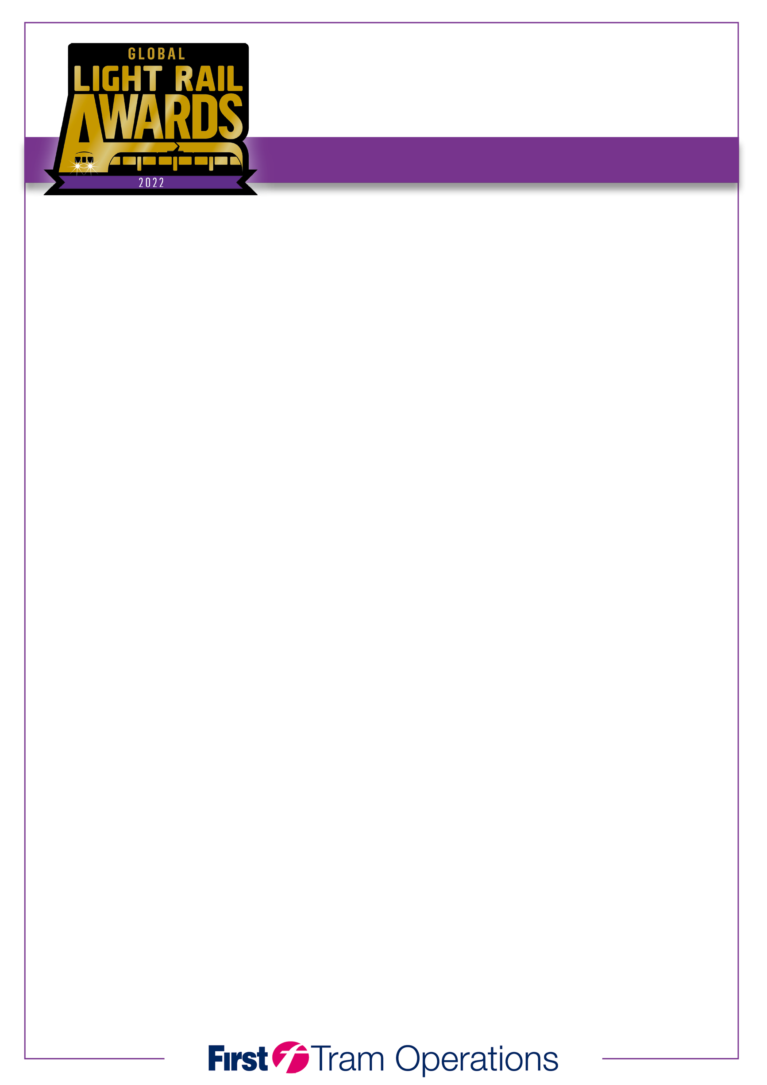

Qualifying dates: July 2021 – July 2022

Closing date: Wednesday 31 August 2022

All entries should be sent to: E-mail: [***awards@lrtap.com***](mailto:awards@lrtap.com)

Post: **2022 Global Light Rail Awards, 13 Orton Enterprise Centre, Bakewell Road, Orton Southgate, Peterborough, PE2 6XU UK**

by no later than Wednesday 31 August 2022. PLEASE ATTACH SUPPORTING MATERIAL/IMAGES.

For further information about any aspect of the awards, call us on +44 (0)1733 367604 or e-mail ***awards@lrtap.com***

|  |  |
| --- | --- |
| Entrant |  |
| Outline of entry |  |
| Supporting elements |  |
|  |  |
| **Entry submitted by:** |  |
| Name |  |
| Position |  |
| Email |  |
| Tel no |  |
|  |  |
| **Counter signatory:** |  |
| Name |  |
| Position |  |
|  |  |
| **Award will be received by:** |  |
| Name |  |
| Position |  |

**ENTRY CRITERIA**

**• All entries must be submitted on a maximum of ten pages and accompanied by at least three high-resolution images in .jpeg or .tiff format. You are free to include supporting brochures, videos and other media.**

**• If supplying printed submissions, please submit 3 copies of each entry for judging purposes.**

**• Entries can be submitted into more than one category.**

Project of the Year

<EUR50m