**2023 HONOURS**

**WINNER:** Keolis Hyderabad - Power Supply Management

**HIGHLY COMMENDED:** Aecom - Ontario Line Immersive Sound Studio

**HIGHLY COMMENDED:** KeolisAmey Docklands - Custom House AI

Technical Innovation

of the Year

GENERAL GUIDANCE FOR SUBMISSIONS

> The Global Light Rail Awards are free to enter.

> Entry submissions are preferred in digital PDF format, although can be supplied as printed copies.

> Please include high-resolution photographs, diagrams and graphics to support your entry where applicable.

> Award entries should be a minimum of 2 pages and a maximum of 10 pages.

> Submissions of the same entry for more than one category are welcomed with additional cover sheets.

> Award entries must clearly demonstrate the positive results the project/initiative and how those results have been measured.

> If the aim of the project was to provide a solution to an existing problem, please make sure you describe the previous situation and the subsequent positive changes as a result of your initiative.

> Testimonials are highly recommended, for example from passengers, clients or partner organisations.

> If your entry has already won awards elsewhere, please tell us as this supports its credibility.

> Award entries will be accepted up to the deadline of FRIDAY 9 AUGUST 2024.

> You will be informed if you’ve made the final shortlist. The Judging Panel’s decision is final and no correspondence will be   
entered into.

Awards categories will be judged based upon the following criteria:

> Direct benefit

> Innovation or thinking differently

> Problem solving

> Added value

> Value for money (for example, cost and time savings)

> Teamwork and collaboration

**CATEGORY SPECIFICS**

**Light and urban rail systems and their suppliers constantly strive for perfection… and are always finding innovative new ways to improve their systems and processes. The judges look forward this year to honouring more projects or initiatives that have transformed the way we design, plan, build, operate and maintain to deliver the highest possible standards of service.**

Entry criteria and submission advice

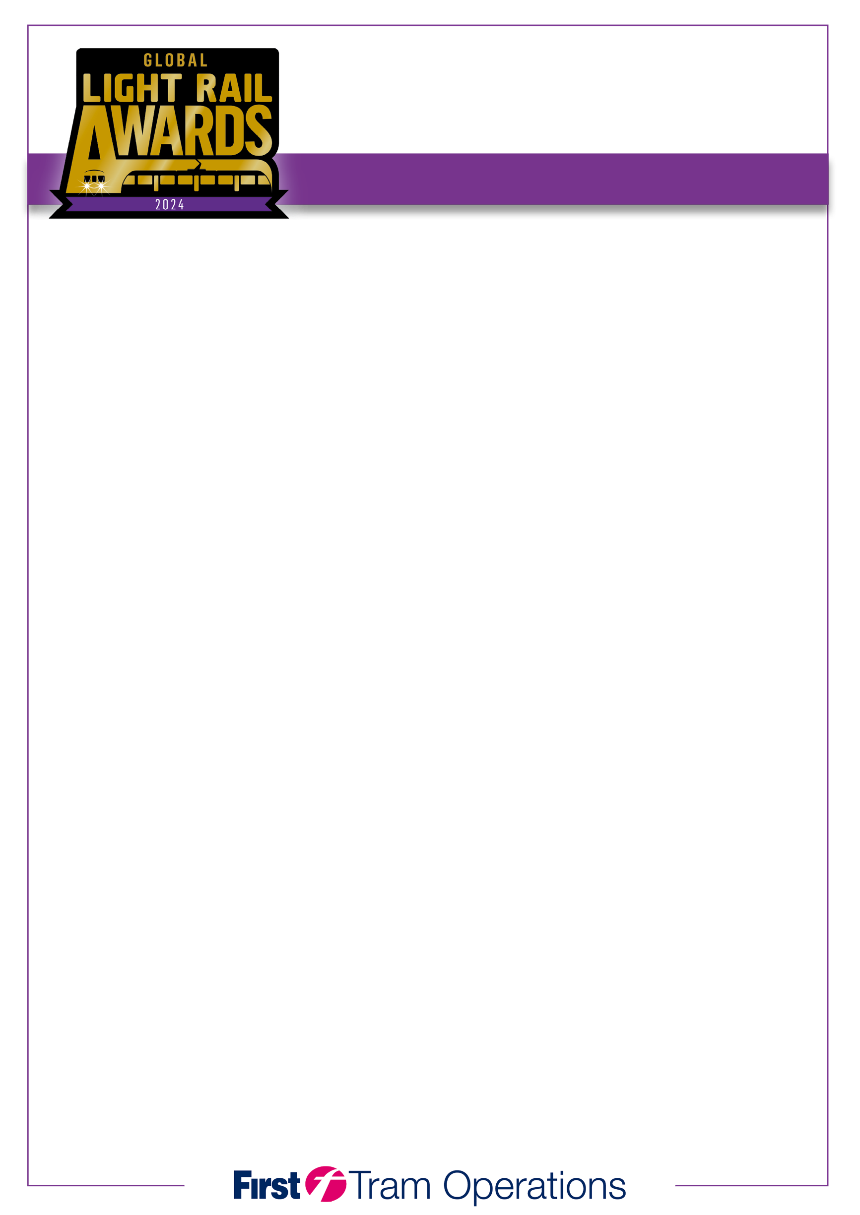

Technical Innovation

of the Year

Qualifying dates: July 2023 – July 2024

Closing date: Friday 9 August 2024

All entries should be sent to: E-mail: [***awards@lrtap.com***](mailto:awards@lrtap.com)

Post: **2024 Global Light Rail Awards, 13 Orton Enterprise Centre, Bakewell Road, Orton Southgate, Peterborough, PE2 6XU UK**

by no later than Friday 9 August 2024. PLEASE ATTACH SUPPORTING MATERIAL/IMAGES.

For further information about any aspect of the awards, call us on +44 (0)1733 367604 or e-mail ***awards@lrtap.com***

|  |  |
| --- | --- |
| Entrant |  |
| Outline of entry |  |
| Supporting elements |  |
|  |  |
| **Entry submitted by:** |  |
| Name |  |
| Position |  |
| Email |  |
| Tel no |  |
|  |  |
| **Counter signatory:** |  |
| Name |  |
| Position |  |
|  |  |
| **Award will be received by:** |  |
| Name |  |
| Position |  |

**ENTRY CRITERIA**

**• All entries must be submitted on a maximum of ten pages and accompanied by at least three high-resolution images in .jpeg or .tiff format. You are free to include supporting brochures, videos and other media.**

**• If supplying printed submissions, please submit 3 copies of each entry for judging purposes.**

**• Entries can be submitted into more than one category.**